USER MANUAL

This document explains how to use and run this project.

Once you unzip the the project, you will see one folder, one application, one ppt, and two word documents.

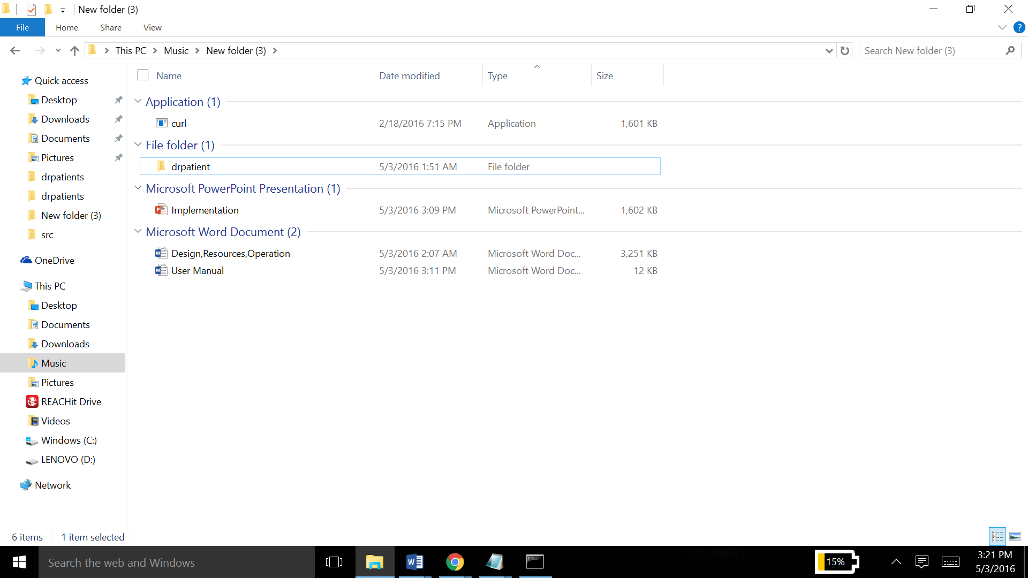

The drpatient folder is the actual project. The curl application is a utility needed to perform all the CRUD operations on the service.

The Implementation ppt shows how the webservice is deployed, and the various operations that can be performed on it.

Extract this whole zip file into an appropriate location and then open the drpatient folder. You should already have a server installed, if not download one (such as Tomcat server) from the internet.

Copy the source location of the opened folder and open that directory in a command line. Then follow the steps given in the implementation ppt to run and perform operations on the web service.

